‘THE Ashtavaidya Play’ – Theatrescience at the National Centre for Biological Sciences (NCBS), Bangalore, 2011.
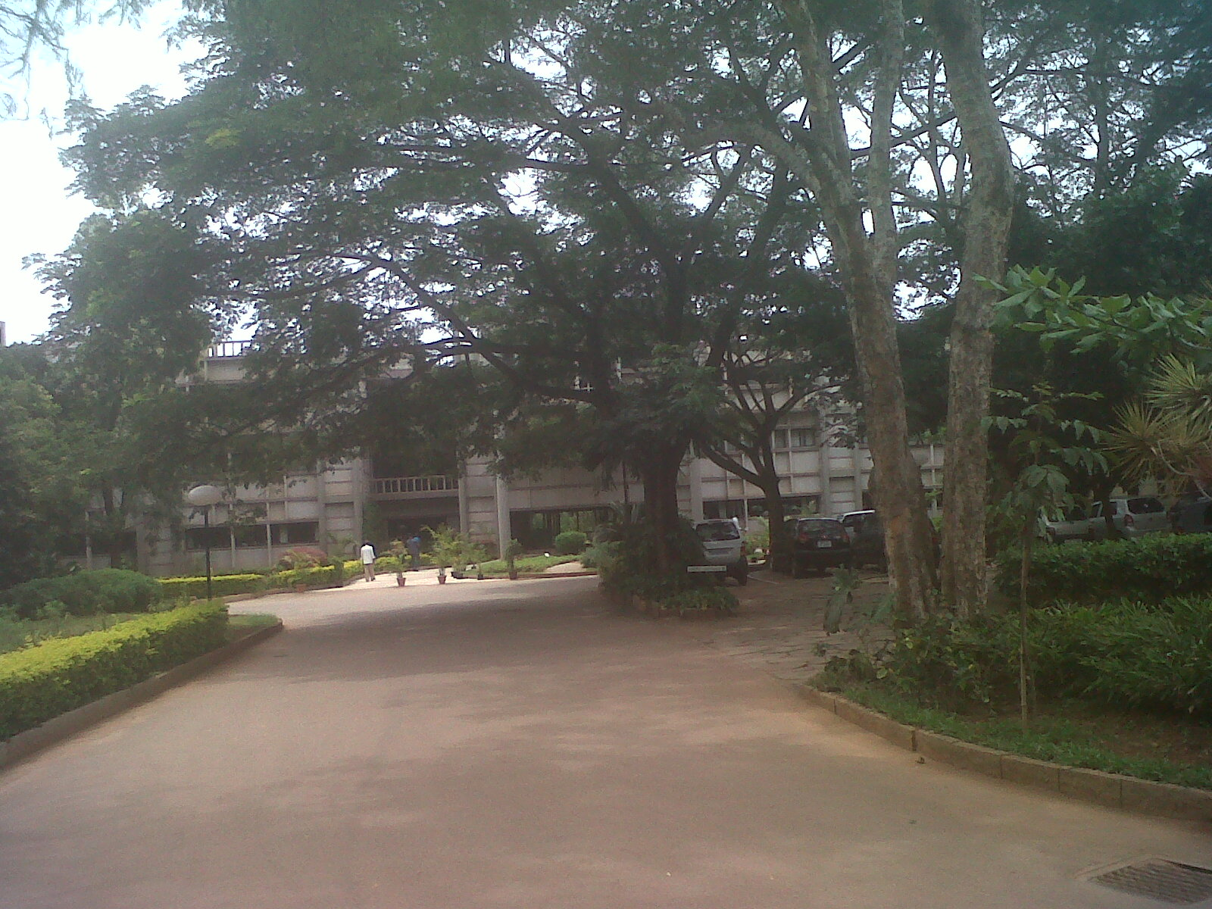
National Centre for Biological Sciences – Main entrance.

Context.
Theatrescience is a small UK theatre company that, among other things, uses drama (participation) and theatre (presentation) to explore societal, political, economic and ethical biomedical science issues (see www.theatrescience.org.uk). The company was founded by Rebecca Gould and Jeff Teare in 2002.
Theatrescience has worked with many and various scientists and theatre practitioners in the UK and India and has connections in various other countries such as Brazil and the USA. Theatrescience has also worked with health workers and drama practitioners in Uganda.
All our projects have been independently evaluated (see documentation on website). Our work has been represented internationally at conferences in Switzerland, India, South Africa and Argentina. Theatrescience plays have been seen in the UK, India, Uganda, Brazil and Australia.
Theatrescience began working in India in 2006 and at NCBS in 2007. Various projects have been undertaken at NCBS since then including the creation of three plays (about Gangetic pollution, forest ecology and PTSD) all performed in India and one in London (see website).
Our main colleague/collaborator at NCBS is Dr Mukund Thattai. When discussing a project for 2011 he suggested we look at the research done by Annamma Spudich and Indhudharan Menon on the Keralan tradition of Ashtavaidya medicine beginning with an article in ‘Current Science’ (Vol 99, no 4). Ashtavaidya is a development from Ayurveda that occurred when Ayurveda practitioners arrived in Kerala and began to adapt their remedies to the local flora. This initial research lead to a more general consideration of the place of traditional medicine in modern India.
Due to Rebecca being busy with the Royal Shakespeare Company it was decided that Jeff would run the project on his own. (The narrative now moves into the first person.)
Mukund and I then decided that the PhD students involved would not only research and devise the project but perform it themselves, rather than bring in outside actors as done previously. We hoped that this would ‘give them more of a voice’ so that they properly owned the material and make the performance more immediate for their fellow students. We also hoped it might help their general presentational skills, something that many scientists need We also thought that actually performing their own devised work might help the students to ‘say’ things that they otherwise wouldn’t. Creating ‘a safe dramatic space’ for the expression of perhaps difficult thoughts and emotions is a basic tenet of such ‘applied drama’ exercises as this one.
At the time the project was being planned NCBS was starting a ‘Science in Society’ programme of its own run by Soumya James. Jeff therefore began liaising with Soumya and ‘The Ashtavaidya Play’ became the first major ‘Science in Society’ project at NCBS and therefore would appear before members of the public as well as staff and students of NCBS.

Process.
The first session took place on the 26th of September 2011. This comprised an introduction to Theatrescience’s previous work (with video) by me and the subject area under discussion by Mukund. Mukund stressed the need to compare the method of Ashtavaidya with modern science; I was more concerned with the performance style that might be involved.
By the third session nine students had definitely committed to the project. Initial research topics were:
- The effect of Kerala and its surroundings being a ‘biodiversity hotspot’ on the development of Ashtavaidya.
- The reasons behind the Indian government’s drive to ‘certificate’ Ayurveda.
- How do we define ‘validity’ and ‘efficiency’ in traditional medicine?

An early practical session looked at what individual statements the students might make on the wider subject area of the place of traditional medicine in modern India. I must admit I was expecting a fairly ‘hard-line science’ response from my top-flight PhD biology students but most of the statements they made were in fact generally supportive of the idea that Ayurvedic practice should be preserved. It did need scientific validation but its true value perhaps ‘cultural’. However, there was also some thinking that it could fit less and less in modern Indian society other than as a ‘cosmetic’ or leisure industry entity.

These initial statements became the basis of the first scene of the performance, a semi-Brechtian line-up of dialectically opposed positions.
In the second week it was pointed out to me by two of the male students that the article in ‘Current Science’ had actually been written by one of the women in the group, though she’d never mentioned it. After she’d finally admitted to being the author, her taped interview with Annamma Spuddich and Indhudharan Menon became the basis of the ‘verbatim theatre’ second scene. This mainly dealt with the historic development of Ashtavaidya and its current decline.
Research into the history of Ashtavaidya then lead to the writing of a third scene, set in the past, which took a slightly comedic look at a senior Ashtavaidya practitioner training his son in the tradition whilst ignoring his daughter. This was contrasted with a further scene set in the present day in which a female scientist and her protégée attempt to ignore the male research student in their lab. The serious intent of these two scenes was to compare process – the ‘five tests’ of Ayurveda v the ‘designed experiment’ approach of modern science.
These two scenes were followed by a definitely comedic presentation of the ‘Short History of Medicine’ (from root to prayer, to potion, to pill, to antibiotic and back to root) widely available on the internet).
The specific methods of Ashtavaidya were then touched upon in a TV News scene contrasting traditional medicine with modern ‘Ayurveda lite’. The ‘Ayurveda’ cosmetic business woman argued: ‘It is impossible to export Ayurvedic medicines and oils except as herbal dietary supplements’; the traditional practitioner retorting: ‘This is not Ayurveda let alone Ashtavaidya!’
The next section comprised a poem written by one of the women on the subject of whether modern science could really address traditional wisdom illustrated by another woman dancing the sense of the words.
Next came an apparent confrontation between a scientist and a modern ‘Ayurvedic saleswoman’. This was based on research which Dr Sumantra Chattaji told us about which he thought actually demonstrated positive Ayurvedic medical effects.
The piece finished with another poem, originally written by one of the male students, which ended:
‘We should preserve what’s rightly ours, traditional or new,
And who decides just what we keep? It should be me and you!’

Performance.
Originally only one performance was scheduled for staff, students and the general public. However, given increasing outside interest, and as the show was now part of the ‘Science in Society’ programme, it was decided that there should be one ‘in-house’ and one fully public performance.
The ‘in-house’ performance took place on the 21st of October 2011. The venue was the main lecture hall. Much previous Theatrescience work had been shown in the outside, amphitheatre space but I decided that this would be too exposing for the students’ performance skills, especially vocally. Also ‘The Ashtavaidya Play’ was more to do with exploration (research) and experimentation (the danced poem) than pure performance. However, the Lecture Theatre space was not ideal theatrically, especially in terms of lighting.
The students performed to pretty much a ‘full-house’ of their peers which must have been challenging for them to say the least. One of the students had made a PowerPoint presentation to introduce the scenes and I provided some simple sound effects and links. The show went well and the discussion afterwards showed that the audience had been fully engaged in the issues the performance raised.
The second performance, a week later, for outside interested parties, parents and friends, was even fuller. Soumya had organised an after-show panel discussion but neither she nor Mukund could be there. I attempted to host the occasion but by then I was already working on my production of ‘Lysistrata’ at the Jagriti Theatre so there was little opportunity to re-work, or even just re-rehearse.
However, the second performance went brilliantly despite a cueing hiccup from me, for which I apologise to the cast. At this point I really have to acknowledge the good will and commitment of the students involved, especially in my absence.
However, the panel discussion was not so successful. We were lucky that Annamma Spuditch could attend and she spoke well but two other panel members (pro and anti ‘Ayurveda lite’) argued from somewhat entrenched positions. Also the Panel left little room for student participation in the discussion. Luckily one student managed to finish the session with a very good summary of the main argument of the show (general v specific medicine) which is included in the short video available on the Theatrescience website.
After this performance the students were asked if they would do the show at an Ayurveda Research Institute that some of us had visited as part of our research. This performance took place the following week. I was unable to attend but the students informed me that the show had been well received though with fewer laughs than at NCBS.
After this performance I was approached as to the possibility of mounting a similar project with Ayurveda students. However, logistical and financial considerations make it unlikely that this will ever happen.

Reflections.
When Ashtavaidya was first suggested as a subject I thought that it would be culturally interesting to see what modern, ‘western’-trained Indian students would think about traditional medicine. I have worked extensively with medical students in the UK (at the Peninsula School of Medicine and Dentistry) and assumed a similar scepticism about ‘alternative’ therapies. A few of the early statements made by the NCBS students were pretty anti-Ayurveda but as we began work on devising/rehearsing it quickly became apparent that many of them had positive, first-hand experience of Indian traditional medicine. Most of the stories told did begin with ‘My Mother/Aunty took me’ but the general reaction was that whatever the treatment was, it had done some good.
Perhaps more importantly, the students thought that the Ayurveda tradition should be preserved for cultural reasons, because it was ‘Indian’.
In 2010 I wrote a play called ‘Darwin in India’ funded by the British Council which was read and discussed at NCBS. My aim was to ‘explore the influence of Darwin on Indian culture and thought’. Some of the swamis I talked to on my first research trip told me in no uncertain terms that ‘Darwin is wrong’ but even some of the scientists I met seemed to be able to believe in evolution in the lab and forget about it at home. When I jokingly asked at what point on the journey home did they ‘flip’ I was informed that the carrying of two antithetical ideas in the brain at the same time was ‘not a problem’. Now, I am not a scientist but even for me, given my generally dualistic western education, this was something of a problem. To most westerners things at least should be either black or white. Grey exists but it is generally frowned upon, at least by journalists and politicians. The students on the Ashtavaidya project, whilst wanting more scientific research into the real efficacy of Ayurveda, thought of it as more of a cultural worthy construct more than something to be sternly tested by scientific method. Ayurveda it seemed was seen as in some way standing for ‘Indian identity’ and perhaps should therefore not be tested too rigorously, at least so long as it was not doing any actual harm. So perhaps you could believe in scientific method in the lab but traditional Ayurveda at home.
An NCBS scientist who had worked with us on another project asked the students if the process of putting the Ashtavaidya show together really had allowed them to say things they otherwise wouldn’t. The students didn’t really appear to think so. Perhaps I expected the opposite. After all they were students at a leading scientific research institute, so making statements in favour of ‘non-scientific’ medicine should have been difficult? Another western assumption perhaps.
Six years of working in India (not just with Theatrescience) has perhaps demonstrated to me that the so-called rift between art and science is no wider than that between a a ‘western’ and ‘eastern’ way of thinking. And yet, perhaps such ‘rifts’ are actually pretty meaningless. In the words of the ‘The Ashtavaidya Play’ poem:
‘Can I demystify a dosha?
Should I?
Can I break a kaayam into bits and put it back together again?
Can I decide between the parts and the whole?’
One thing I’m fairly certain about. If you were to try a similar project with UK Biology PhD students you might get one to write a poem but you’d be extremely unlikely to find one who could illustrate it in classical dance.

Finally thank you to Yadugiri, Prabahan, Carmen, Nelima, Urbashi, Rajan, Apana, Somya and Balaji and all the other people at NCBS (especially in the office and on the front desk) who enabled the project to happen.

Jeff Teare
Co-director Theatrescience
June 2012.
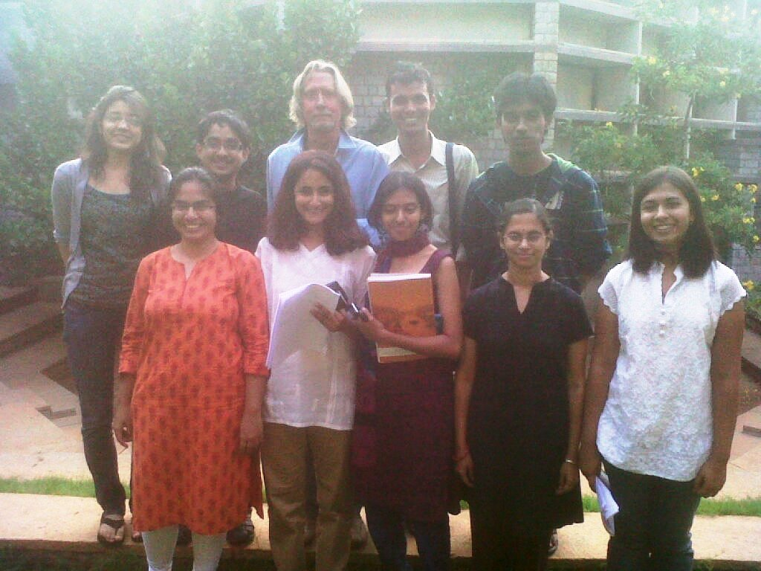
Jeff with the ‘Astavaidya’ Cast.

Abstract:
Theatrescience is a small UK theatre company that, among other things, uses drama (participation) and theatre (presentation) to explore biomedical science issues. In 2011 Theatrescience worked at the National Centre for Biological Sciences to create a theatre piece about Ashtavaidya (Ayurveda).
The Report looks at:
- The history of Theatrescience using drama and theatre at NCBS to explore specifically Indian biomedical issues.
- The decision to create a performance piece on the role of traditional medicine in modern India.
- The reasons (applied drama) for involving PhD Biology Students as deviser/performers’
- The process by which the theatre piece was made.
- The performances and post-show discussions.
- Some reflections on the project as a whole.

Key Words:
Drama
Science
Biology
Theatrescience
Ashtavaidya
Ayurveda

Jeff Teare – Short CV
Co-Director - Theatrescience 2002-2012.
Artistic Director - Made In Wales Stage Company 1995-2000.
Associate Director – Theatre Royal, Stratford East 1986-1995.
Staff Director – Royal National Theatre.
Associate Director – The Young Vic.
Associate Director – Leicester Phoenix Theatre.
Studio and TIE Director – Derby Playhouse.
Jeff has directed over 120 theatre productions, mainly new plays but also Shakespeare, Chekhov, Brecht, Pinter etc. and various pieces of Community, Applied and Children’s Theatre.
He has also written over a dozen performed plays, made various videos/documentaries and edited and contributed to a number of books.

