Theatrescience 2002-2012 – A Brief History.

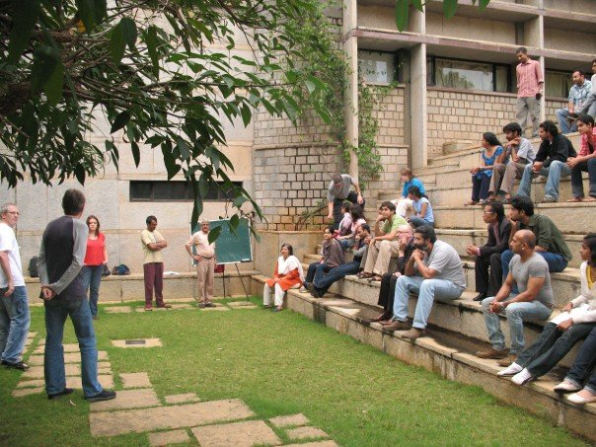
Theatrescience Workshop at the National Centre for Biological Science, Bangalore, India, 2006.

Theatrescience was formed in 2002 by Rebecca Gould and Jeff Teare (with Professor Anthony Pinching as senior science advisor and Simon Turley as resident writer) to work in theatre in the UK both as consultants and producers/theatre practitioners. (See www.theatrescience.org.uk).

Theatrescience mainly, although not exclusively, uses theatre and drama to illuminate and influence science and it uses science to enrich and challenge theatre. Theatrescience’s objective is to break down the barriers between two allegedly divided disciplines to the enduring benefit of both. It undertakes productions of biomedical science-based plays, commissioning of scripts, workshops, organization of festivals and exchanges. Its work engages schools, communities, scientists and artists.

2002-4

Theatrescience’s first project was the Newbury Science/Drama Festival involving six schools at the Corn Exchange Theatre, Newbury. This was followed by the ‘Plymouth Science Drama Festival (2003) involving four schools at The Drum Theatre, Plymouth.
Experience from these festivals was codified into the The Drama of Science programme which was published and rolled-out nationally to schools with workshops in Bristol, London, Southampton, Stoke-on-Trent and Manchester in 2004.

‘Imagining the Future’, a workshop involving scientists, writers and theatre practitioners, was run at the Theatre Royal Plymouth in February 2003. This became the basis for The Theatre of Science.

2004-5

The Theatre of Science ran at the Theatre Royal, Plymouth as well as in various schools and venues in Devon and Cornwall. It included professional productions (‘Seeing Without Light’ by Simon Turley and ‘Still Life’ by Charles Way) at The Drum theatre, a large community event, the making of videos, workshops, public presentations and discussions as well as performances by seventeen schools (mainly about HIV/Aids and genetic predisposition). The scripts of the professional productions were published and an extensive evaluation undertaken.

It was intended that the title the ‘Theatre of Science’ should then be transferred to another UK theatre. However, instead, Rebecca and Jeff decided to transfer the model of work to India (see 2006).

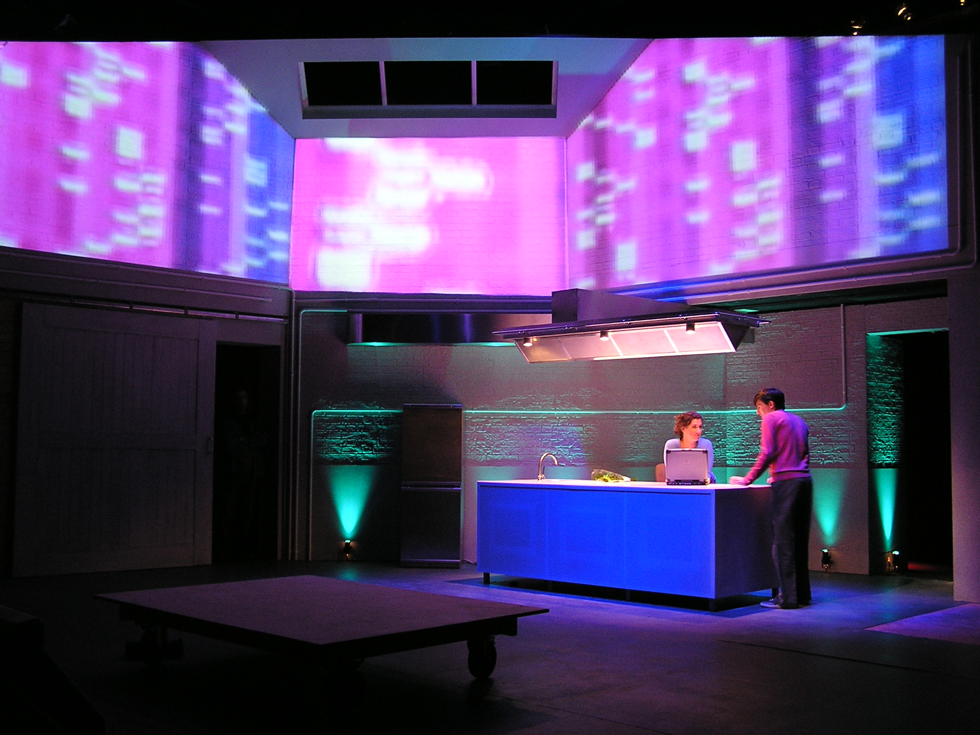
Scene from ‘Seeing Without Light’ by Simon Turley, Drum Theatre Plymouth 2005.

In November 2005 Jeff and Simon presented a Theatrescience Workshop at the ‘Science on Stage’ Conference at CERN, Switzerland.

2006

Theatrescience began working in India in the summer of 2006. Meetings with writers, actors, students and directors took place in Kolkata, Mumbai and Bangalore. Workshops were also undertaken with theatre professionals in Kolkata and Bangalore as well as two at the University of Mumbai. These formed the basis for ‘Imagining the Future India’.

2007-2008

Imagining the Future India (Oct 2007).

This workshop/festival, in association with ART/Jagriti, Bangalore, followed on from the Plymouth workshop in 2003 and the initial work in India in 2006.
It comprised an 8-day event in Bangalore which stimulated inter-cultural and interdisciplinary scientific and dramatic collaboration.
Four of the new plays created then came to London as:

Theatrescience India in London (2008).

The Indian companies involved were The Creative Arts from Kolkata, and the Artistes’ Repertory Theatre/Jagriti from Bangalore.
Writers involved include Gautam Raja, Farhad Sorabjee and Paul Sirett.

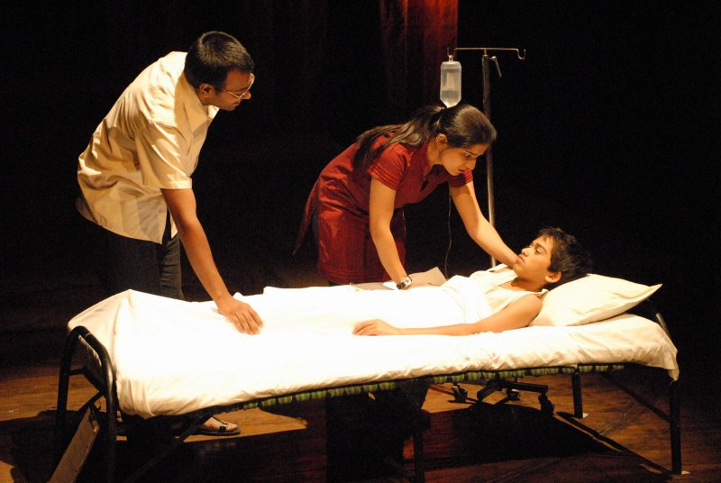
Scene from ‘The Invisible River’ by Gautam Raja. Lillian Baylis Theatre, London, 2008.

‘The Invisible River’ and ‘Crab Soup’ (The Creative Arts) were performed at the Lilian Baylis Theatre, ‘Bad Blood Blues’ by Paul Sirett and ‘Idiot Wind’ received public readings at Soho Theatre.
A presentation was also made at the Nehru Centre (Indian Embassy).

‘Something Somatic’ by Simon Turley.

This new play ‘about’ CFS/ME was performed by Theatrescience in Plymouth and London in Nov/Dec 2008.

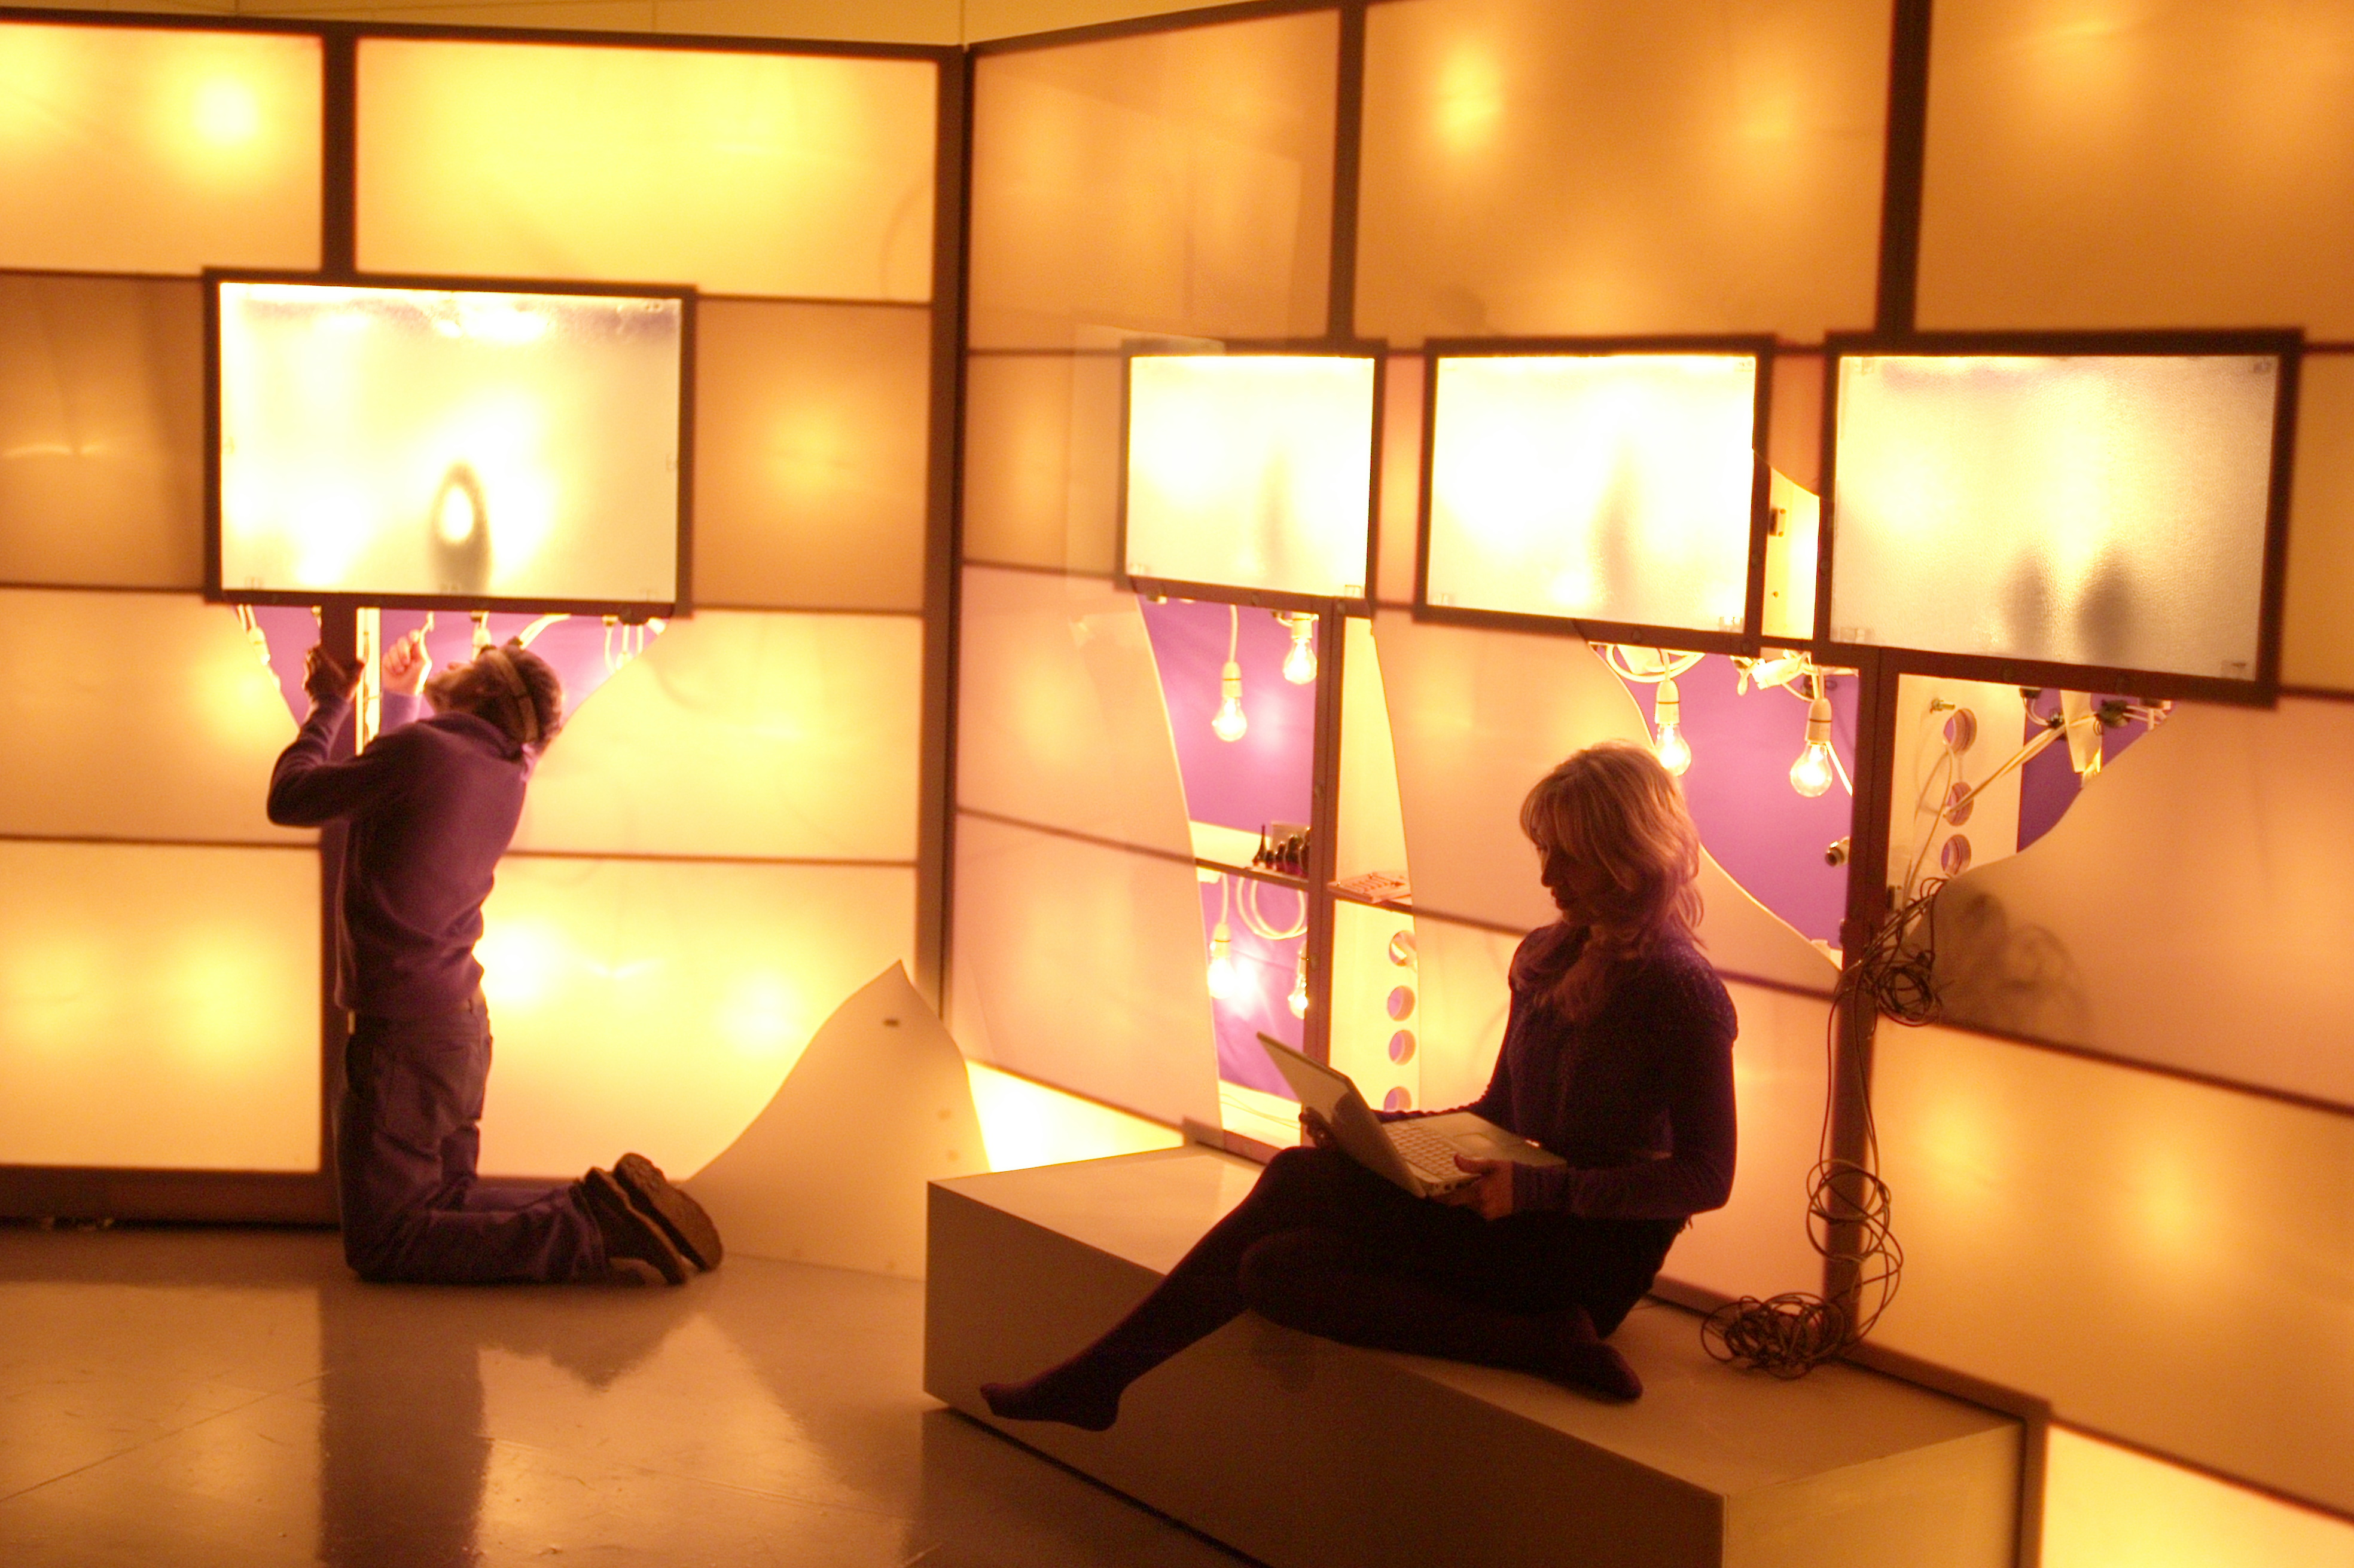
Scene from ‘Something Somatic’ by Simon Turley, Wellcome Space, London 2007.

In June 2008 the Wellcome Trust invited Theatrescience to perform extracts from this production at its meeting of Public Engagement advisors at the Eden Project, Cornwall (UK).

Also, in December 2008, Rebecca represented Theatrescience at the first Wellcome International Public Engagement Conference in Durban, South Africa.

2009

Theatrescience returned to India in January 2009 for a month-long residency at the National Centre for Biological Sciences to develop work directly from current research there. This resulted in two new plays.
One, ‘The Clearing’ by Gautam Raja, concerned the public health issues involved in forest ecology. The other, ‘Amol’s Stories’ is about PTSD and memory and was performed twice as part of the
residency.

Jeff attended the Campus Euroamerican in Buenos Aires in March 2009 where his Theatrescience workshop was a feature event.

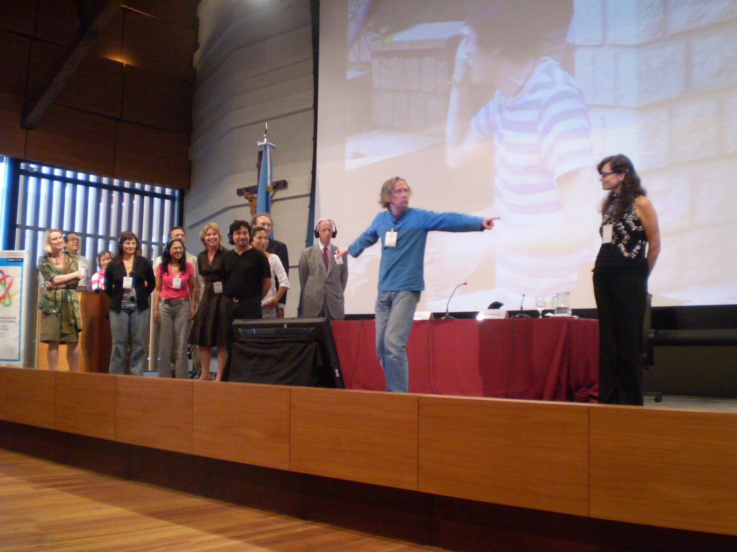
Theatrescience Workshop at the Campus Euroamerican, Beunos Aires, Argentina, 2009.

In May 2009 Bad Blood Blues by Paul Sirett, originally developed at Imagining the Future India, was produced at the Theatre Royal, Stratford East in London. This play is concerned with HIV research in sub-Saharan Africa and the notion of ‘informed consent’ in drug trials.

In October 2009 Theatrescience began an educational science/drama project, ‘Acting Against Worms’, in association with SCI (Imperial College) and the Ugandan Health Ministry in the Busia district of Uganda about the prevention of Bilharzia. Workshops were held with medical staff, local drama practitioners and in nine schools.

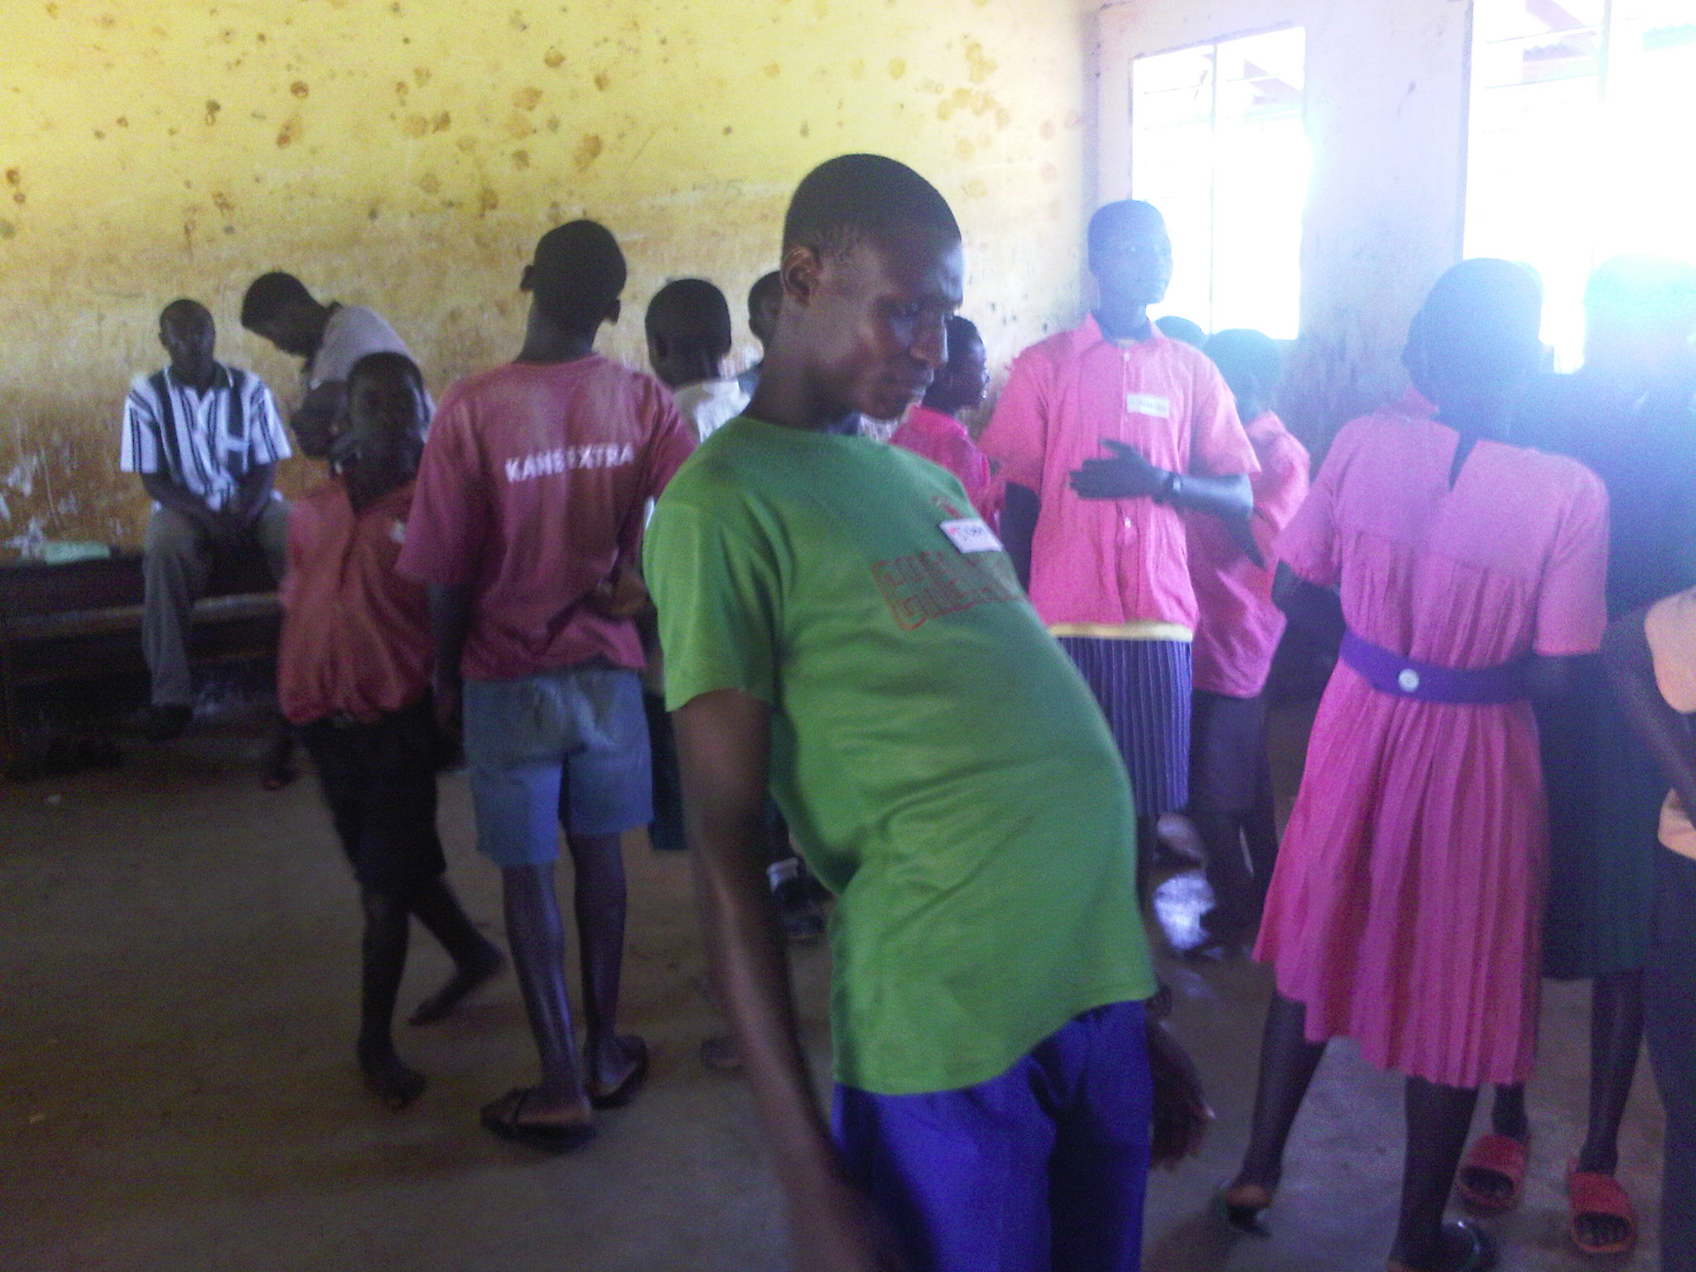
Bilharzia Workshop in a Busia school, Uganda 2009.

In November 2009 Theatrescience held an initial workshop at the Eden Project for ‘Not My Fault’. This major programme of work involved six writers, eight scientists and ethicists, actors, students and members of the general public and has been archivised by Warwick University. The general subject was ‘Genetic Diversity and Health’. Six scripts were commissioned from this workshop.

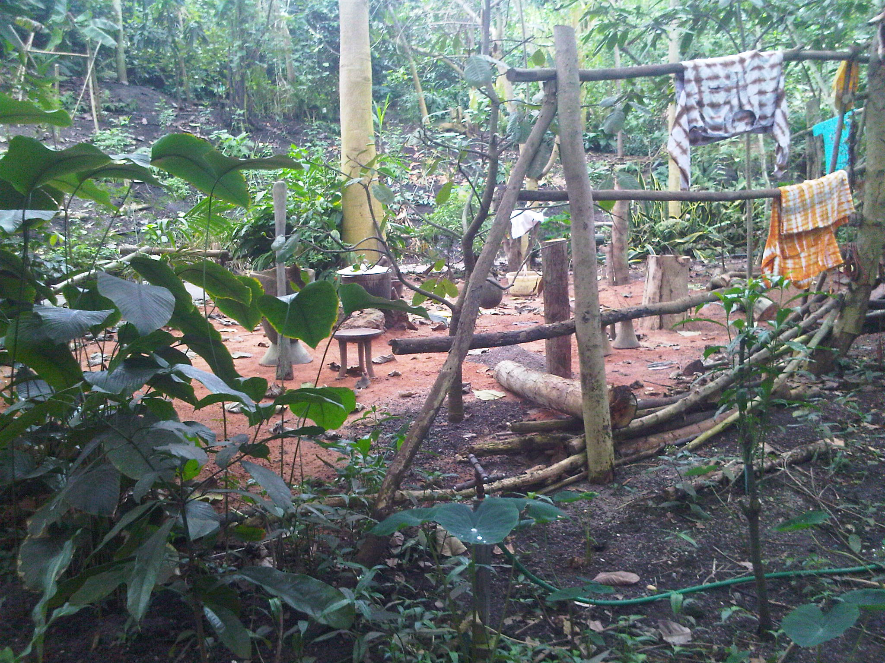
Eventual Eden location for ‘State of Nature’ by Simon Turley.

In December 2009 Rebecca and Dr Jessica Mordsley (Theatrescience Associate) curated the Second Wellcome International Public Engagement Conference in Bangalore. Theatrescience (Jeff, Simon, Paul and Arundhati Raja)) delivered two presentation/workshops.

2010

The Uganda project was completed in April 2010. A Festival was held with performances from five schools to an audience of over 500 students, local people and dignitaries. This project was formally evaluated by SCI and this evaluation has been publicised in ‘The Drum Beat’.

In June 2010 ‘The Clearing’ by Gautam Raja was produced at the Alliance Francaise, Bangalore by Jagriti/ARC (Theatrescience partner).
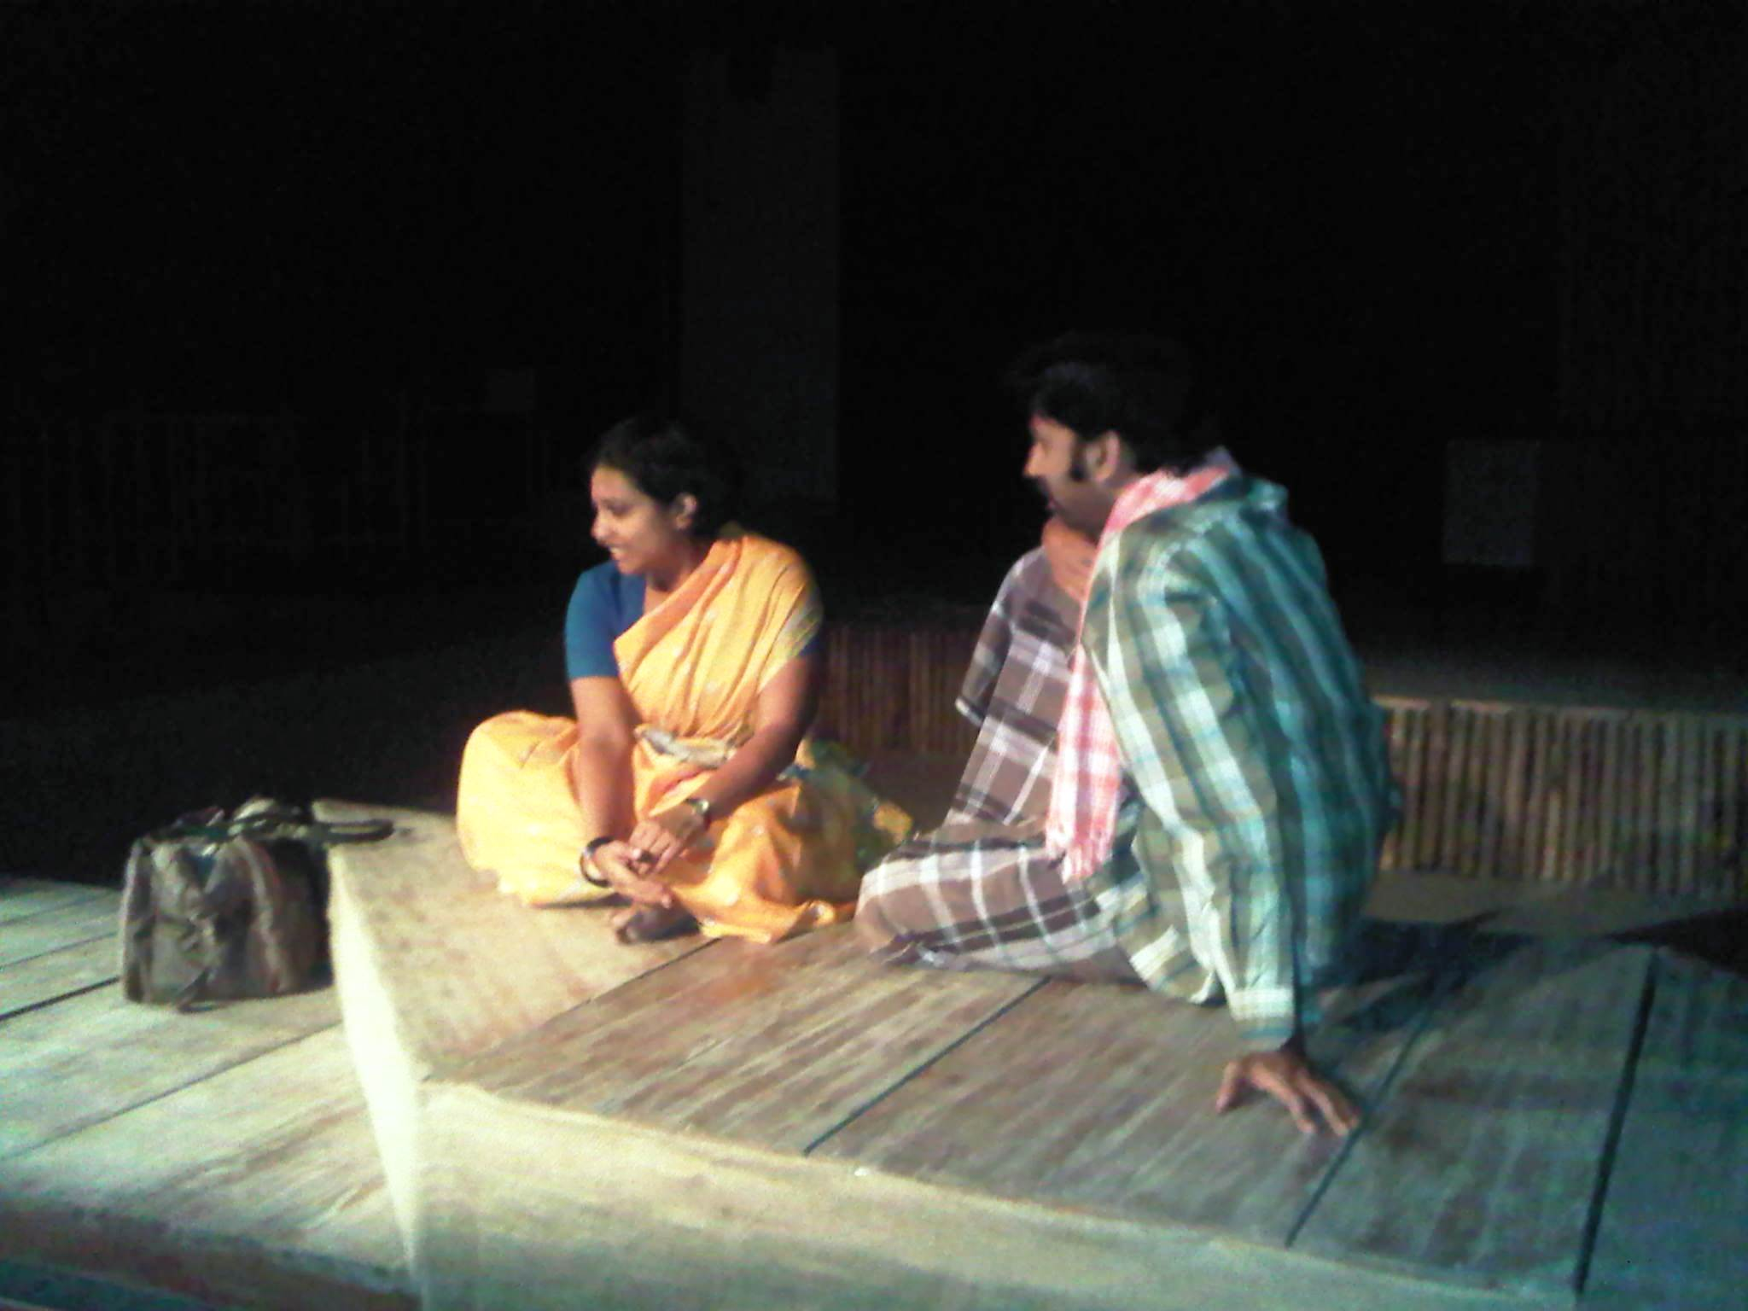
Scene from ‘The Clearing’ by Gautam Raja, Bangalore 2010.

In June 2010, Jeff’s play ‘Darwin in India’ received a rehearsed reading at NCBS followed by a discussion on the influence (or not) of Darwin on Indian thought and culture. The play was supported by the British Council.

In July 2010, as the first event in the ‘Not My Fault’ Programme, students from Plymouth’s Ridgeway School presented their devised piece about genetic inheritance at Eden.

In November 2010, despite severe problems with flooding, ‘Not My Fault’ culminated at Eden with three short plays by emerging writers being performed in the Temperate Biome and Simon Turley’s ‘State of Nature’, about Lewi Bodies Dementia, in the Tropical Biome (as well as at The Lost Gardens of Helligan and Truro Hospital, with a try-out at The Pleasance in London).

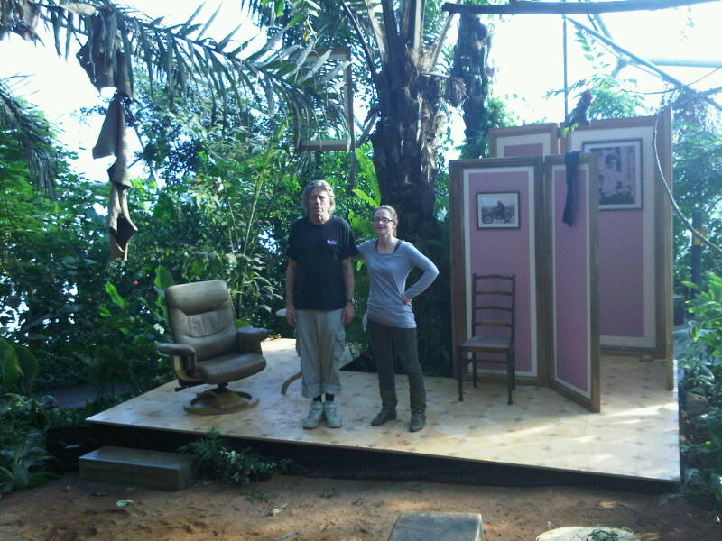Scene from ’State of Nature’ by Simon Turley at the Eden Project, Nov, 2010.

2011

Theatrescience became a Company Limited by Guarantee.

In 2011 Jeff finished five year’s teaching at the Peninsula College of Medicine and Dentistry, under the Theatrescience banner, of a ‘Medicine as Art’ course in how doctors’ attitudes to disease and injury might affect their clinical practice.

In September 2011 Jeff became a Visiting Scholar at NCBS to create a piece of drama about the place of traditional medicine in modern India – The Ashtavaidya Play. This was performed by PhD Biology students to other students and staff, the general public and at an Ayurveda Research Centre.

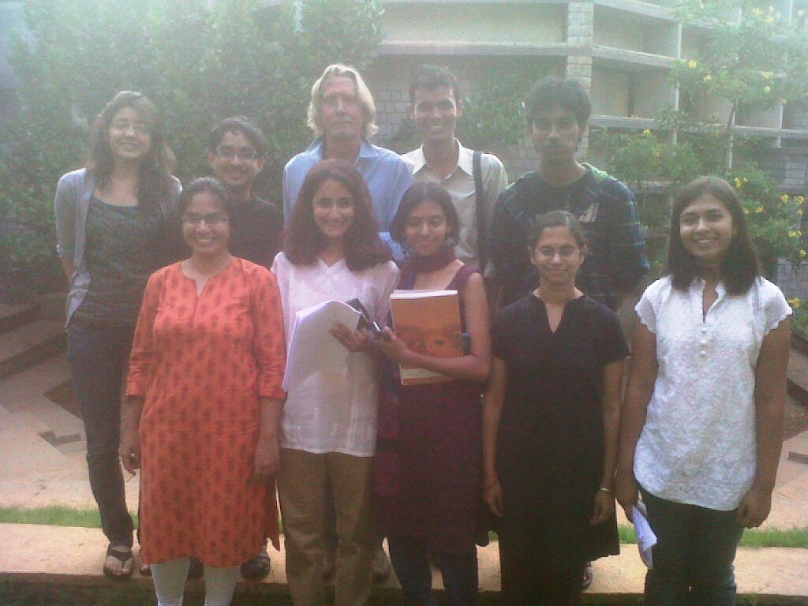
The Ashtavaidya team, NCBS, Oct 2011.

(While Jeff was in Bangalore he also directed his own adaptation of Lysistrata to open the first season at the new Jagriti Theatre.)

Also in 2011 Bad Blood Blues, by Paul Sirett was performed, to critical acclaim, in Rio do Janeiro and Sydney. It is due to be seen again in Sydney in 2012.

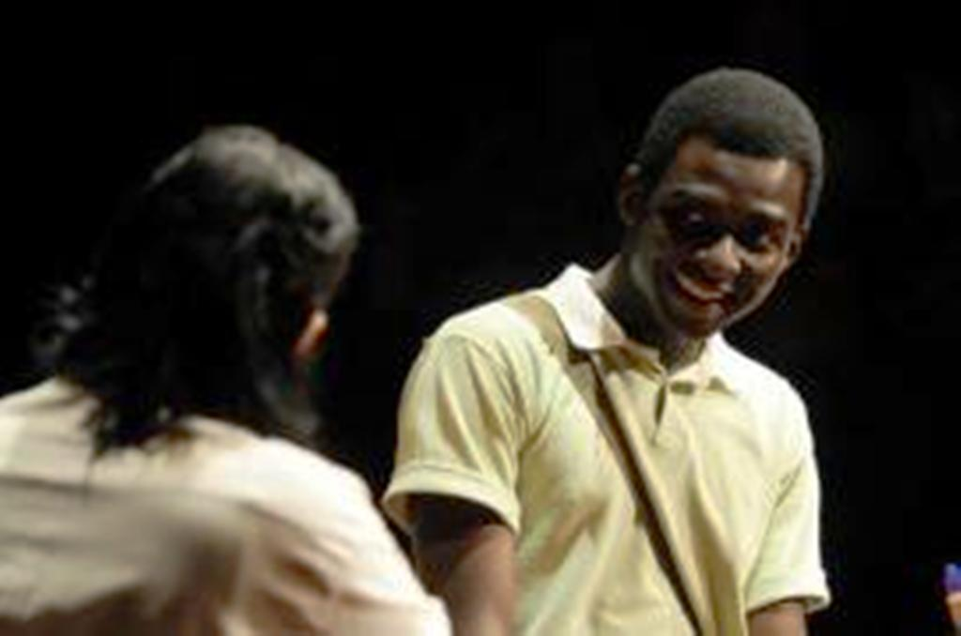
Scene from the Rio production of ‘Bad Blood Blues’ by Paul Sirett.

2012

Theatrescience kicked-off its 2012 programme of work with a presentation of ‘Something Somatic’ at the National BACME Conference in Milton Keynes (UK).

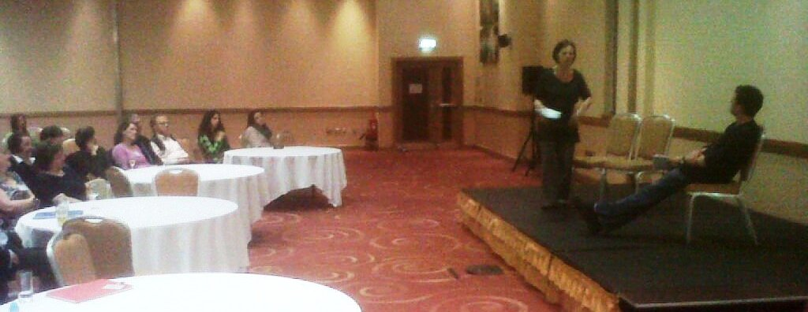

Current plans (March 2012) include possible plays about Nicholas Culpeper and Mikhael Bulgakov and another return to India.

