Theatrescience 2002-2012.

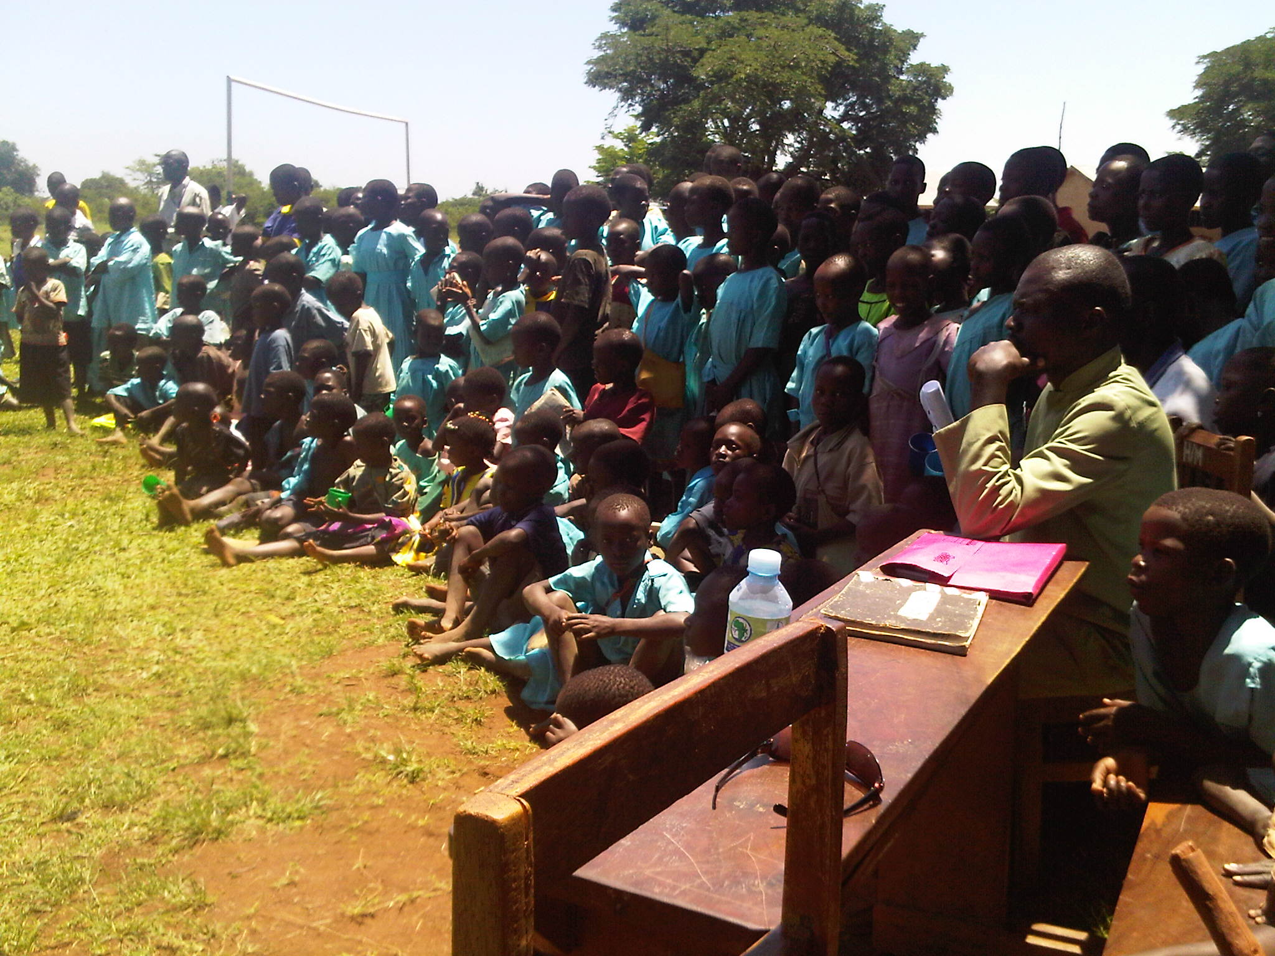
Theatrescience audience in Uganda, 2010.

Context

Theatrescience was formed in 2002 by Rebecca Gould and Jeff Teare (see www.theatrescience.org.uk). Previously they had run the Welsh new-writing theatre company, Made in Wales, and then worked on the Wellcome Trust’s ‘Science Centrestage’ project. Before that, among other things, Jeff had been Associate Director of the Theatre Royal, Stratford East in London.

Theatrescience’s main concern is to explore the cultural, political, economic and ethical issues of biomedical science. It uses theatre and drama to illuminate and influence science and it uses science to enrich and challenge theatre.
In practice this has meant that Theatrescience has introduced theatre practitioners and audiences to subject areas they may not have otherwise come across in a dramatic context and has introduced a means of communication to scientists that they generally would not have otherwise considered. (See the interviews with scientists and science teachers in the ‘Drama of Science’ video on the website).

Theatrescience workshops and performance development processes have also got theatre practitioners and scientists to work closely together. Post-show discussions, workshops and other public engagement activities have also involved scientists, medical practitioners, students and the general public in the development of their dramatic work.

Theatrescience undertakes the commissioning of scripts, productions of plays, the running of workshops and festivals and conferences. Its work engages schools, colleges, research institutes, community organisations, theatre practitioners, scientists and the general public. Specialist science advisors are sought for each project and client/patient groups, where suitable, are also involved.

Much of Theatrescience’s work has been funded by the Wellcome Trust however other support has come from the Arts Council, the British Council, the Peninsula College of Medicine and Dentistry (PCMD - UK) and the National Centre for Biological Sciences (NCBS - India). Our partner organisation in India, other than NCBS, is the Jagriti Theatre in Bangalore.

Theatrescience has worked extensively with medical students at PCMD and biology research students at NCBS. It has worked with many and various scientists and theatre practitioners in the UK and India and has connections in various other countries such as Brazil and the USA. Theatrescience has also worked with health workers and drama practitioners in Uganda.

All our projects have been publicly discussed, either as part of the development process, post-show or at seminars, conferences etc. They have also been independently evaluated (see documentation on website). Our work has been represented internationally at conferences in Switzerland, India, South Africa and Argentina. Theatrescience plays have been seen in the UK, India, Uganda, Brazil and Australia.

Subjects for our work have often come direct from scientific research (especially at NCBS) but have also been suggested by individual scientists (‘Something Somatic’) and theatre practitioners (‘Bad Blood Blues’). Audience feedback has also contributed to many of our productions (‘The Clearing’, ‘Something Somatic’, ‘Amol’s Stories’ etc.).

The Work

Theatrescience’s first project was the Newbury Science/Drama Festival involving six schools at the Corn Exchange Theatre, Newbury in 2002. This was followed by the Plymouth Science Drama Festival involving four schools at The Drum Theatre, Plymouth. Both these projects involved working with students, science and drama teachers and theatre professionals. The students themselves devised and performed their own plays on such subjects as cystic fibrosis, Huntington’s disease, access to genetic medical information etc.

Experience from these two festivals was codified into:

The Drama of Science.

This comprised a handbook and video which were published and made available on-line (see website). The Drama of Science was then rolled-out nationally to schools with workshops in Bristol, London, Southampton, Stoke-on-Trent and Manchester.

Imagining the Future.

This was a workshop involving scientists, writers and theatre practitioners run at the Theatre Royal Plymouth in February 2003. Various long-term connections were made at this workshop including those with Simon Turley (writer) and Professor Anthony Pinching (scientist). Simon became Theatrescience’s resident writer; Tony Theatrescience’s senior science advisor.
Imagining the Future became the basis for our first large-scale theatre project:

The Theatre of Science.

This project ran at the Theatre Royal, Plymouth as well as in various schools and venues in Devon and Cornwall from 2004 to 2005. It included professional productions at The Drum Theatre - ‘Seeing Without Light’ by Simon Turley about HIV research in Africa and ‘Still Life’ by Charles Way about genetic predisposition (both published by Parthian Books), a large community event, the making of videos, workshops, public presentations and discussions as well as performances by seventeen schools.

(Evaluation extract - Everybody [education, theatre and public] was in agreement that this medium of theatre successfully engaged people with thought provoking and informative productions. Students working on their own productions found that they could learn and understand more through this experiential process. Teachers said that students learned more this way than in ordinary Science lessons and were the strongest advocates of theatre as a learning tool).

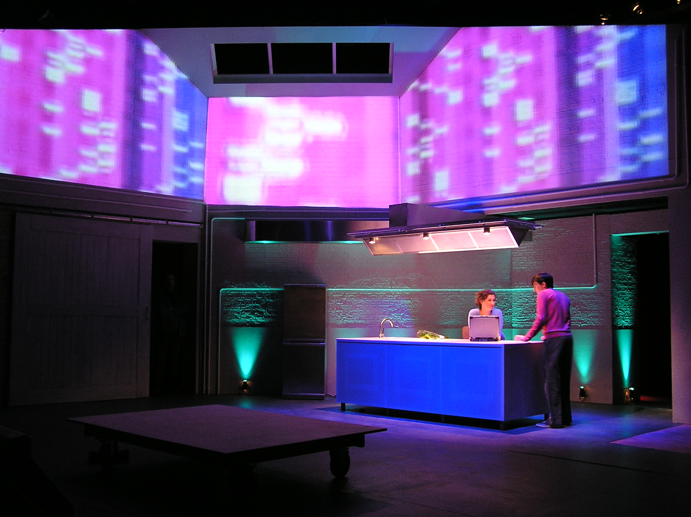
Scene from ‘Seeing Without Light’ by Simon Turley, Drum Theatre Plymouth 2005.

In November 2005 Jeff and Simon presented a Theatrescience Workshop at the ‘Science on Stage’ Conference at CERN, Switzerland. This workshop involved over one hundred educationalists from thirteen countries.

It was intended that the title the ‘Theatre of Science’ should then be transferred to another UK theatre. However, instead, Rebecca and Jeff decided to transfer the model of work to India. This was mainly because Rebecca had already done some work in India for the British Council and Jeff had worked extensively in British Asian theatre in London and they both thought that operating in India would sharpen and focus the company’s work in a way not really possible in the UK.

Theatrescience began exploratory work in India in the summer of 2006. Meetings with writers, actors, students and directors took place in Kolkata, Mumbai and Bangalore. Workshops were also undertaken with theatre professionals in Kolkata and Bangalore as well as two with students at the University of Mumbai. These formed the basis for:

Imagining the Future - India.

This workshop/festival, in association with the Artistes Repertory Theatre (ART)/Jagriti in Bangalore, followed on from the Plymouth workshop in 2003 and the initial work in India in 2006.
It comprised an 8-day event in Bangalore which stimulated inter-cultural and interdisciplinary scientific and dramatic collaboration. Workshops, readings and performances were undertaken at various venues in Bangalore including, for the first time, at NCBS.
Four of the new plays created were then brought to London as:

Theatrescience India in London.

The Indian companies involved were The Creative Arts from Kolkata, and ART/Jagriti from Bangalore.
Writers involved included Gautam Raja, Farhad Sorabjee and Paul Sirett.

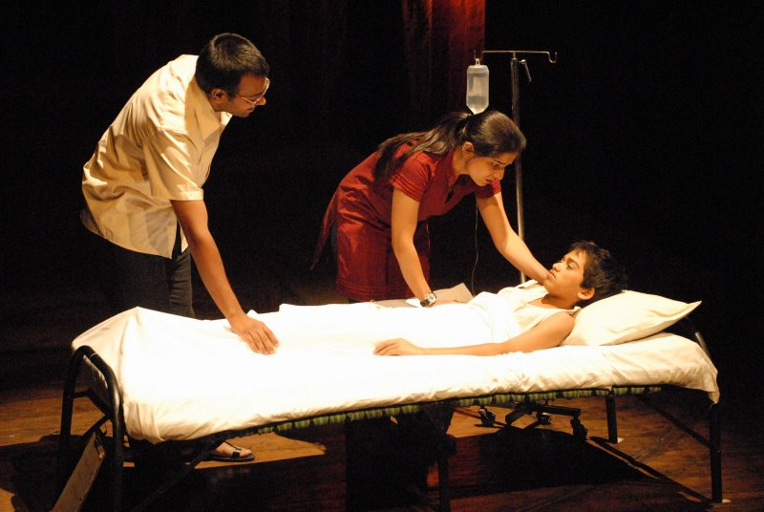
Scene from ‘The Invisible River’ by Gautam Raja. Lillian Baylis Theatre, London, 2008.

‘The Invisible River’ by Gautam Raja and ‘Crab Soup’ (The Creative Arts) were performed at the Lilian Baylis Theatre. ‘The Invisible River’ is about the socio-political (religious) effects of pollution in the Ganges and ‘Crab Soup’ about women living with HIV in India. ‘Bad Blood Blues’ by Paul Sirett (about drug trials in Africa) and ‘Idiot Wind’ by Farhad Sorabjee (about attitudes to autism in India) received public readings at the Soho Theatre.
A presentation was also made at the Nehru Centre (Indian High Commission).

(Evaluation extract - In conclusion, Theatrescience India in London succeeded in achieving increased public engagement with biomedical scientific issues, and made many new connections between cultures, continents, disciplines, individuals, and organisations).

‘Something Somatic’ by Simon Turley.

This new play ‘about’ CFS/ME (the condition is never actually mentioned) was performed by Theatrescience in Plymouth and London in Nov/Dec 2007. It was developed over two years by Simon, Tony and Jeff with input from a large number of CFS/ME sufferers, careers and medical practitioners. Various presentations were also made at medical conferences.

(Evaluation Extract - The consistency of positive audience response across the three evaluated performances demonstrates that, while many were drawn to the play because of the issues it addressed, its success as an exciting piece of theatre is not dependent on the extent to which the audience is engaged in these themes. When questioned about what was most enjoyable over 50% of the audience referred to the 'theatricality' of the piece – set, lighting, sound, direction and acting – indicating the importance of the quality of the dramatic experience).

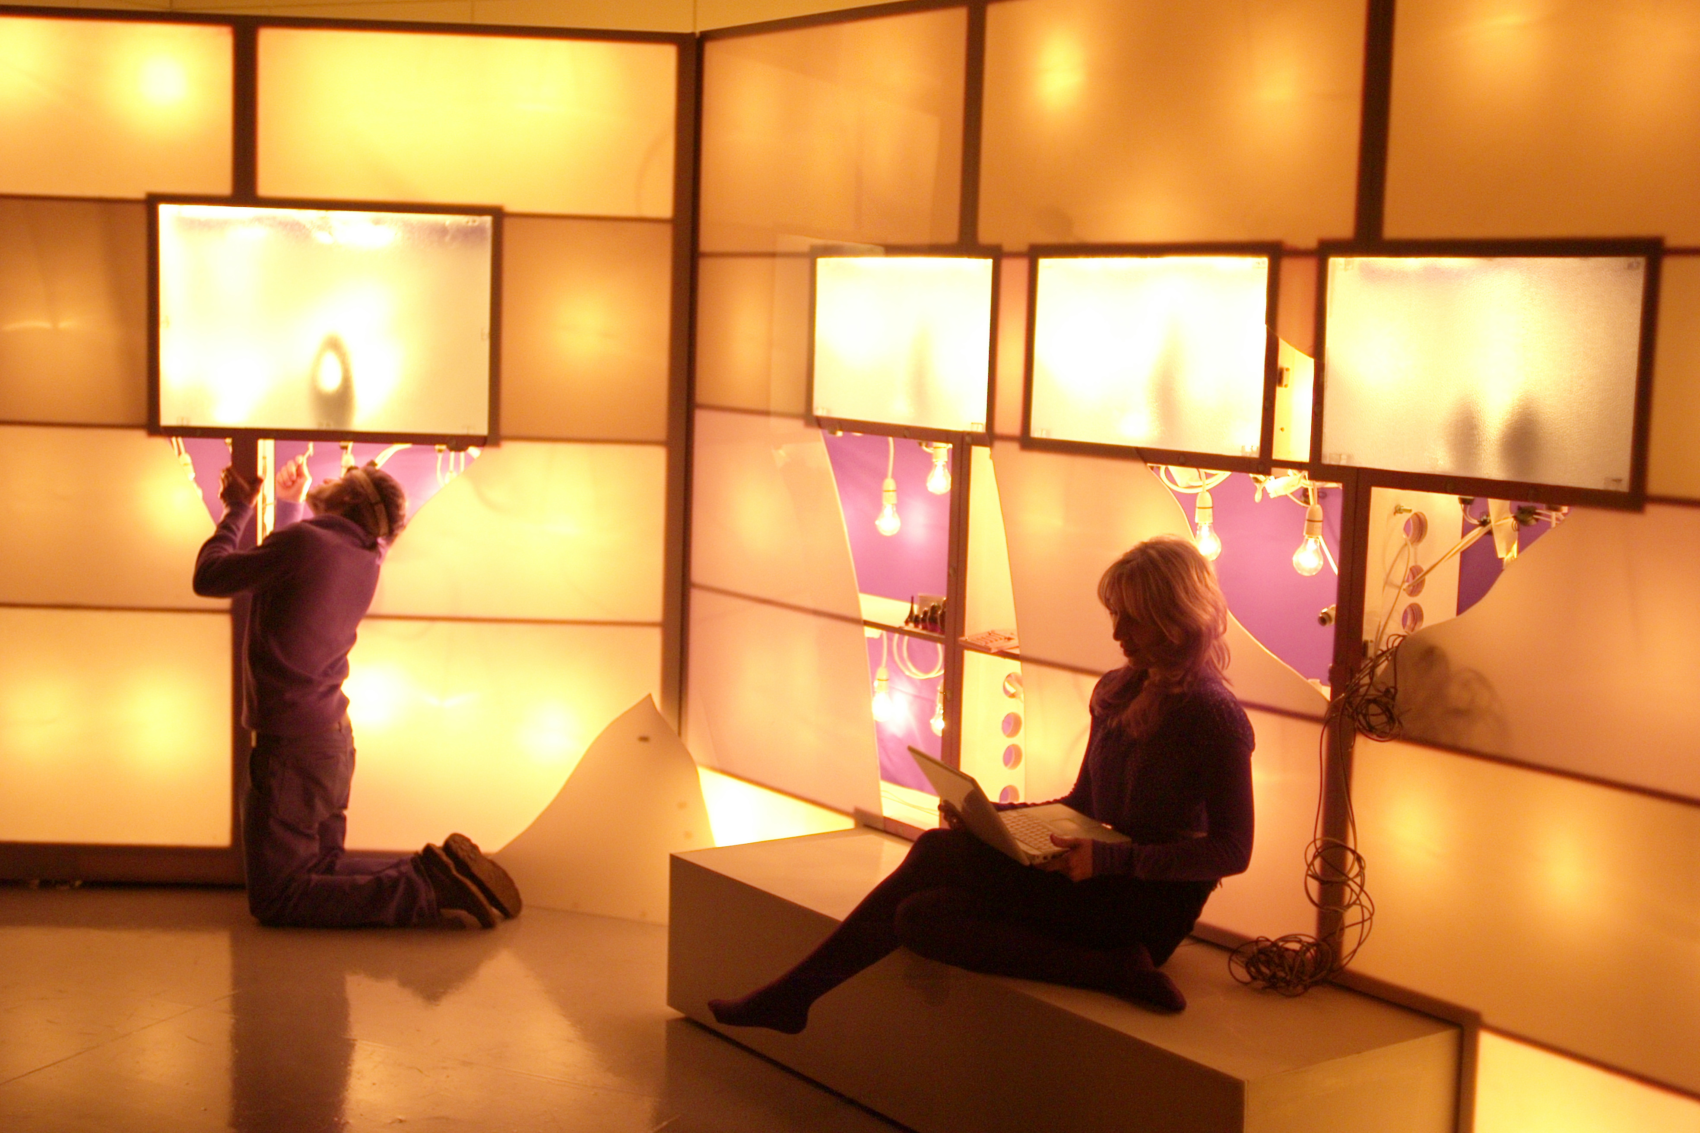
Scene from ‘Something Somatic’ by Simon Turley, Wellcome Space, London.

In June 2008 the Wellcome Trust invited Theatrescience to perform extracts from this production at a meeting of its Public Engagement advisors at the Eden Project, Cornwall (UK).

In December Rebecca represented Theatrescience at the first Wellcome International Public Engagement Conference in Durban, South Africa.

Also, in 2008 Tony, Simon and Jeff contributed to the Wellcome publication ‘Creative Encounters’ on the subject of ‘Dramatic Clinical Spaces’.

(Tony Pinching – ‘As a team from varied disciplines working on the Theatrescience project, we have engaged in dialogues and discourses that have increasingly taken us from fairly straightforward issues of securing veracity towards establishing a deeper and wider authenticity. This journey should give us, and others, greater insights into the interfaces between our humanity/identity and the processes through which we explore outer and inner worlds).

Residency at the National Centre for Biological Sciences.

Theatrescience returned to India in January 2009 for a month-long residency at NCBS to develop work directly from current research there. This resulted in two new plays.
One, ‘The Clearing’ by Gautam Raja, is concerned with some of the public health issues involved in South-Indian forest ecology. The other, ‘Amol’s Stories’, is about PTSD and memory and was performed twice as part of the residency.

In March Jeff attended the Campus Euroamerican in Buenos Aires where his Theatrescience workshop was a feature (plenary) event. It largely dealt with international perspectives on the ‘two cultures’ of art and science.

In May 2009 Bad Blood Blues by Paul Sirett was produced at the Theatre Royal, Stratford East in London.

Acting Against Worms.

In October 2009 Theatrescience began an educational science/drama project about Bilharzia, in association with SCI (Imperial College) and the Ugandan Health Ministry in the Busia district of Uganda. Initially this was conceived purely as a public information activity but the work finally produced was much more concerned with social and economic issues than the mere presentation of preventive information (see material on website). Workshops were held with medical staff, local drama practitioners and in nine schools. Students in the schools were then encouraged to develop their own pieces of drama.

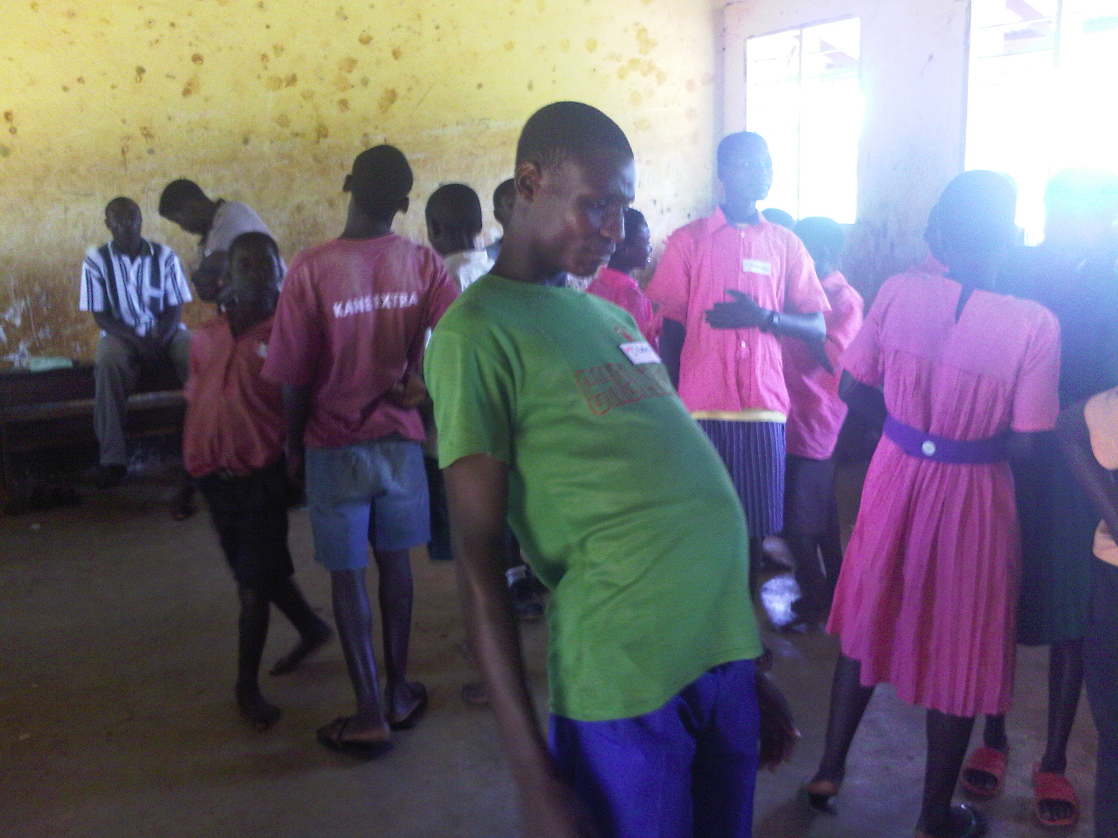
Bilharzia Workshop in a Busia school, Uganda 2009.

The Uganda project was completed in April 2010. A Festival was held with performances from five schools to an audience of over 500 students, local people and dignitaries. This project was formally evaluated by SCI and this evaluation has been publicised in the pan-African publication, ‘The Drum Beat’.

In December 2009 Rebecca and Dr Jessica Mordsley (Theatrescience Associate) curated the Second Wellcome International Public Engagement Conference in Bangalore. Theatrescience (Jeff, Simon, Paul and Arundhati Raja from Jagriti) delivered two presentation/workshops.

In June 2010 ‘The Clearing’ by Gautam Raja was produced at the Alliance Francaise, Bangalore by Jagriti.

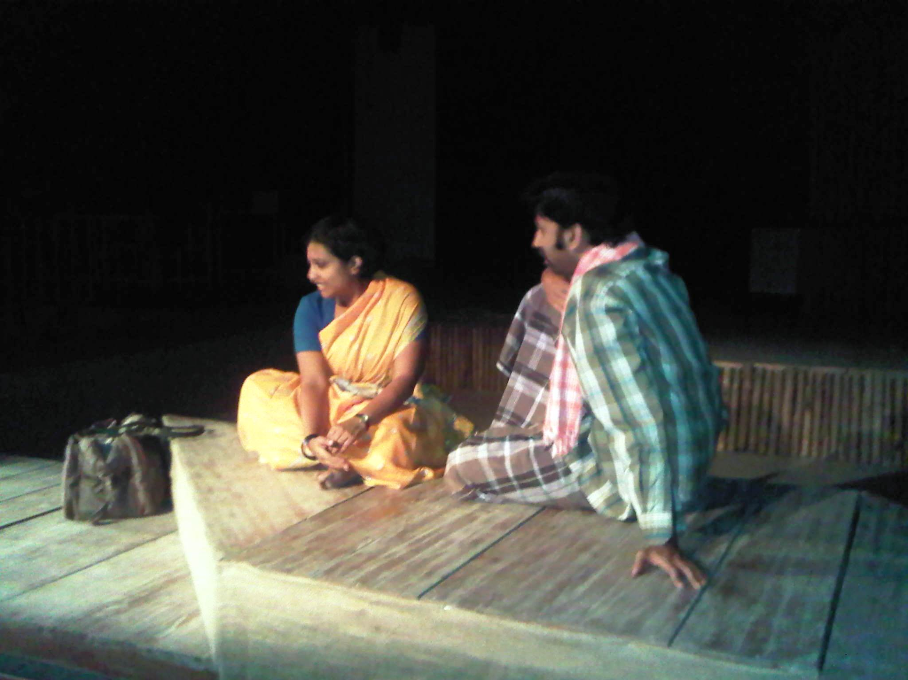
Scene from ‘The Clearing’ by Gautam Raja, Bangalore 2010.

In 2009 Jeff received a ‘Darwin Now’ award from the British Council to develop a piece about the influence (or not) of Darwin on Indian thought and culture. This involved two research trips talking to Indian scientists and religionists. In June 2010 the resultant play ‘Darwin in India’ received a rehearsed reading at NCBS followed by a discussion with research scientists. This event has proved crucial in the development of Theatresciene’s thinking on the social-cultural aspects of the company’s work and fed directly into ‘The Ashtavaidya Play’ project (see below).

Not My Fault.

This major programme of work eventually involved six writers, ten scientists and ethicists, fifteen theatre practitioners, over thirty students, at least twenty Eden staff and many hundreds of the general public.

The project started In November 2009 with an initial workshop at the Eden Project in Cornwall (UK). Seminars and discussions were held and an extensive tour of Eden was undertaken (the final performances were to be site specific/influenced).

Six scripts were then commissioned on various aspects of the subject ‘genetic variance and health’. Three of these commissions were with established playwrights and three were with young writers as part of a development programme.

In July 2010, as the first performance event in the ‘Not My Fault’ programme, students from Plymouth’s Ridgeway School presented their devised piece about genetic inheritance at Eden.

In November 2010, despite severe problems with flooding, Not My Fault culminated at Eden with the three short plays by young writers being performed in the Temperate Biome and Simon Turley’s ‘State of Nature’ (about Lewy Bodies Dementia) being presented in the Tropical Biome (as well as at The Lost Gardens of Heligan and Truro Hospital, with a try-out at The Pleasance Theatre in London).

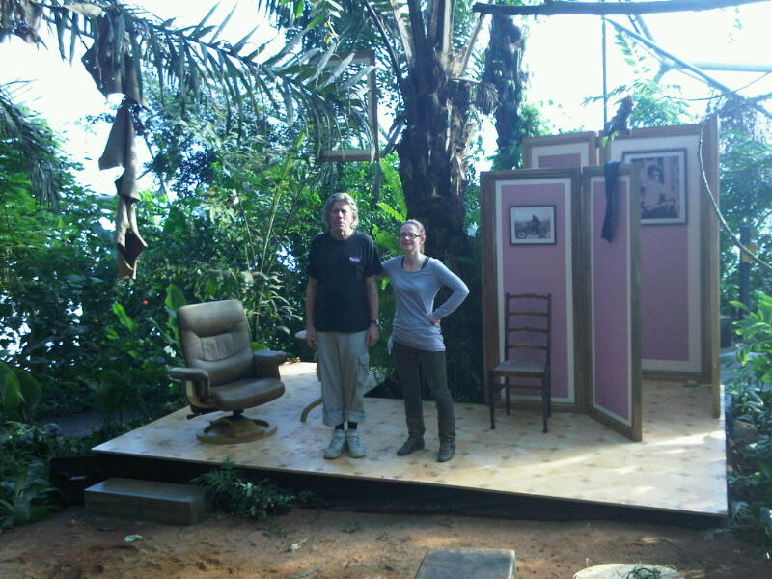Scene from ’State of Nature’ by Simon Turley at the Eden Project, Nov, 2010.

In 2011 Jeff finished five year’s teaching at the Peninsula College of Medicine and Dentistry, under the Theatrescience banner, of a ‘Medicine as Art’ course in how doctors’ attitudes to disease and injury might affect their clinical practice. This work was suggested by Tony Pinching and resulted in over 40 short pieces of drama reflecting the students’ attitudes to various medical conditions, especially CFS/ME. These pieces were written and performed by the medical students involved and presented to and discussed by others. (Some similar work has also been undertaken with Indian medical students and practitioners mainly in the area of medical ethics, based on ‘Bad Blood Blues’).

The Ashtavaidya Play.

In September 2011 Jeff became a Visiting Scholar at NCBS to create a piece of drama about the place of traditional medicine in modern India. Unlike previous work at NCBS the resultant short play was not only researched with students and scientists but devised and performed by PhD Biology students. Three performances were finally given one to other students and staff, one the general public followed by a panel discussion and one at an Ayurveda Research Centre.

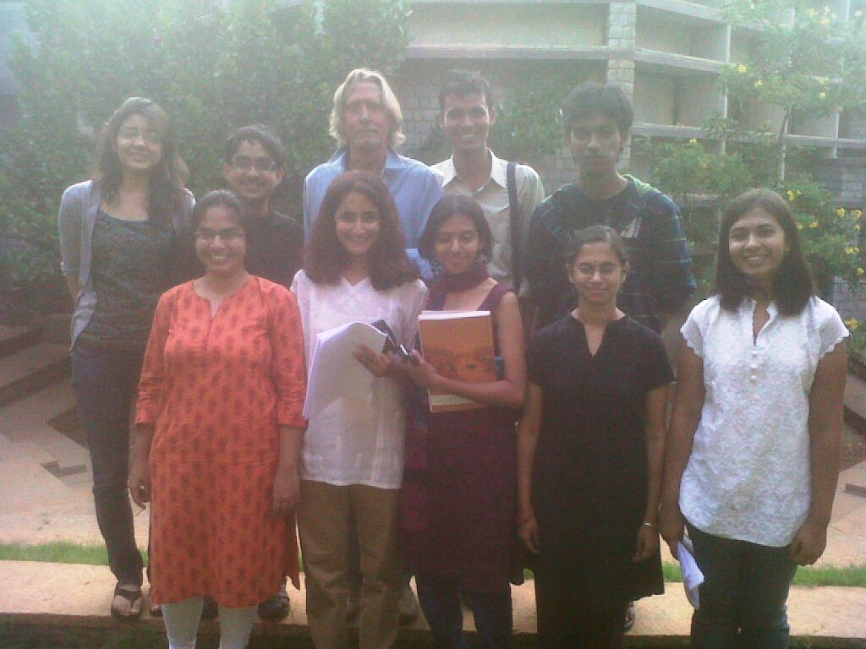
The Ashtavaidya team, NCBS, Oct 2011.

Also in 2011 Bad Blood Blues, by Paul Sirett was performed (to critical acclaim) in Rio de Janeiro and Sydney.

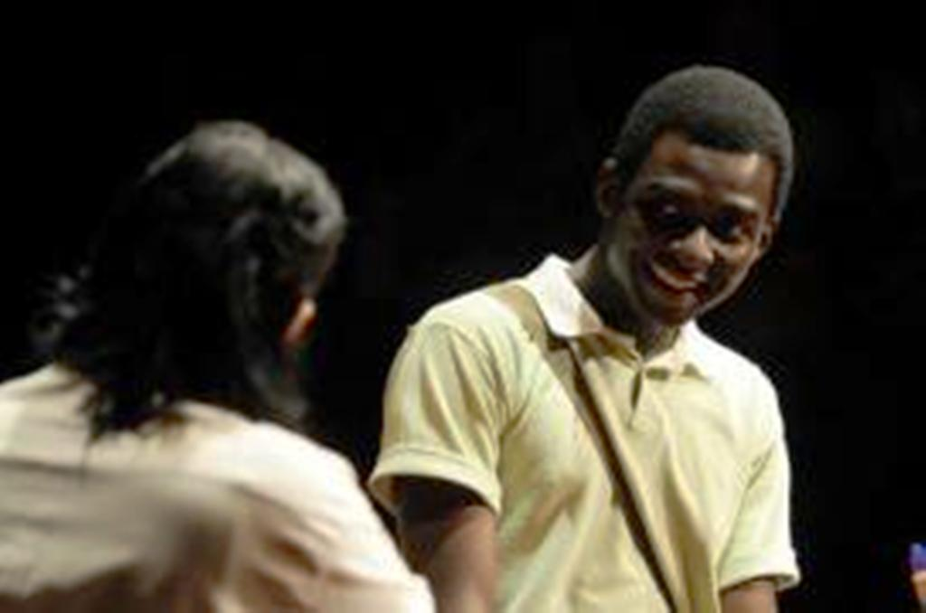
Scene from the Rio production of ‘Bad Blood Blues’ by Paul Sirett.

So far in 2012 (June) Theatrescience has mounted a shortened version of ‘Something Somatic’ by Simon Turley at the National BACME Conference in Milton Keynes (UK) and has lead a three-day Theatrescience Workshop with Oxford School of Drama students in London.

Development

Ten years of work ‘bringing science and theatre closer together’ has resulted in a large number of performances of a wide range of work from a ‘Science Cabaret’ in Plymouth through fringe performances in London, an open air festival in Uganda, various shows in Indian venues from research institutes to brand new theatres to major theatre presentations in Rio de Janeiro and Sydney. Hundreds of theatre practitioners, scientists and medical practitioners have been involved, thousands of students and probably tens of thousands of audience members. All of this has resulted, as it should, in major changes to how Theatrescience works.

We began with projects in schools, largely as a response to working on the Wellcome Trust’s ‘Science Centrestage’ project (2000-2002). We felt it important that the students involved in such projects, often not of their own volition, should at least ‘own’ the work they presented. The shows had to be about science issues that actually concerned them. We also insisted that every school involved had both a science and a drama teacher on the project. On more than one occasion I heard a science teacher say they’d never been in the school’s drama studio before and drama teachers admitting that they’d never even thought of taking a ‘science’ subject as the basis for a devised drama piece before. The best work produced not only did bring science and theatre closer together, often very physically, but also engaged students with current societal, political, ethical and often moral issues. (We probably also taught a bit of science along the way but this is never our main intention).

However, just working in schools didn’t really spread the work wide enough so, with ‘Theatre of Science’ we began working with adult community groups and commissioning playwrights to write plays for general audiences. These plays were then published and given a further life through the website and presentations at conferences etc.

Then, after a while we thought that (mainly) performing only in theatres or to special interest groups was a bit limiting as well. This lead to performing to visitors to the Eden project many of whom were not expecting to see a play at all, let alone one on a subject like dementia or attitudes to aging.

The move to India, as mentioned above, was to do with testing our process in a different, ‘sharper’ cultural context. Some of the work produced, especially the Jagriti productions of Gautam Raja’s scripts, has been artistically outstanding but our other work there especially at NCBS, made us realise that we needed to learn some difficult lessons about cultural imperialism, culturally different approaches to theatre and the intellectual limits of Cartesian dualism in an Indian context.

In one way the last project in India, ‘The Ashtavaidya Play’ at NCBS, brought our work full circle in that the work was devised and performed by the students if, this time, by PhD Biology students. The ‘danced poem’ in the performance (viewable on the website video) perhaps demonstrates that the divide between art and science may not be as distinct in India as many think it still is in the West. These cultural resonances of our work are definitely something we wish to pursue.

Meanwhile the funding situation, both for art and science, becomes ever more difficult in the UK. Undeterred, Theatrescience is currently looking to develop projects exploring:
‘The formation of doctors’ in terms of personal experience and social expectation.
Scientific and social aspects of environmental sustainability.
The changing role of older people (‘Elders’) in different societies.
Malaria prevention.
The role of philanthropists in modern medical research.

Jeff. Teare
Co-director
Theatrescience.
June 2012.

